**Talk Box (Speech Generating Device)**

**User Manual**

Installation:

* Downloading jar File
* Running Jar file to customize buttons and voice inputs.
* Create very own customized Talkbox application.

Here are the steps for configurating the Talkbox depending on user needs

1. Right after running the configuration, it asks for the required number of buttons (For the purpose of guidance, 4 buttons will be chosen):

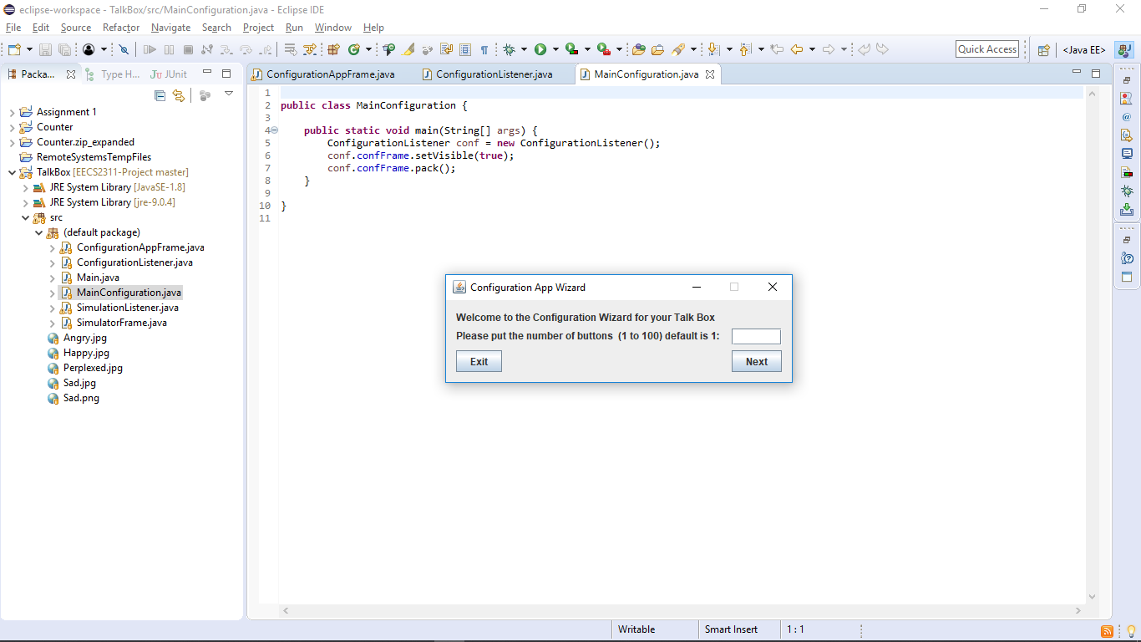

1. Creates the intended number of buttons and then prompts the user to upload the specified image and audio file (unique to user needs)

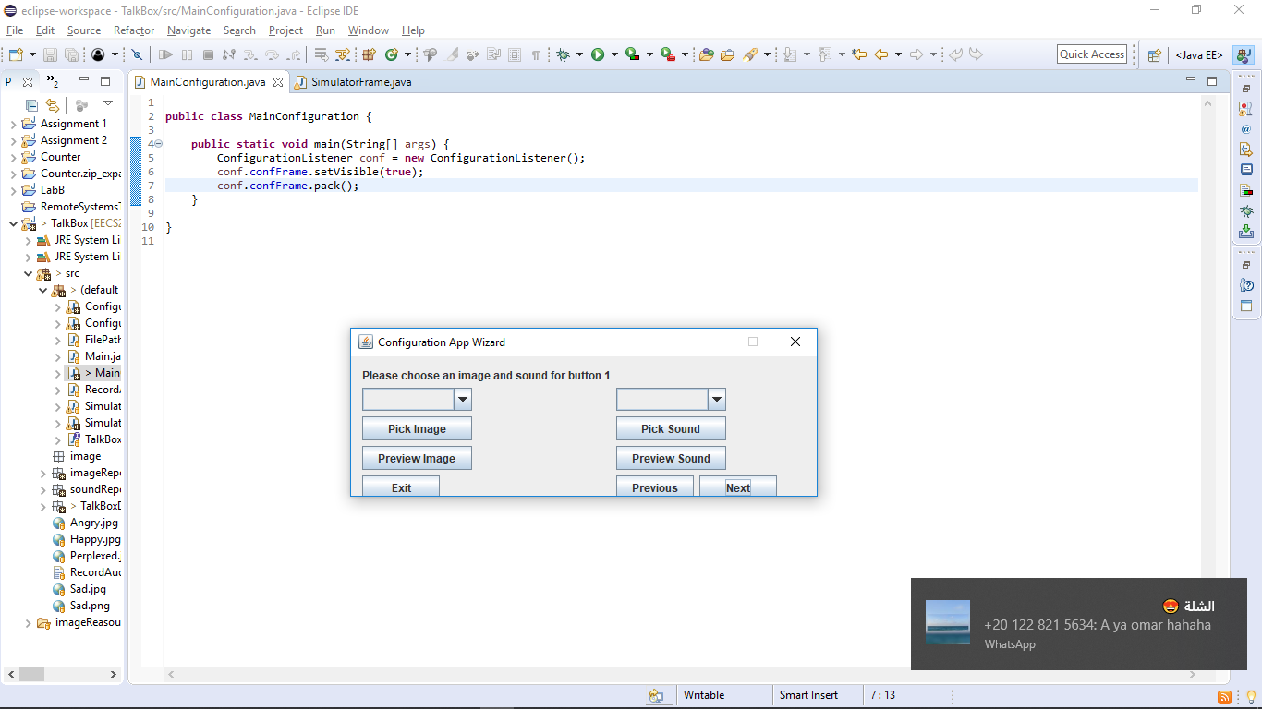

1. In this window there are two drop down fields. They help the user specify how they want to upload the sound or image:
   1. Image:

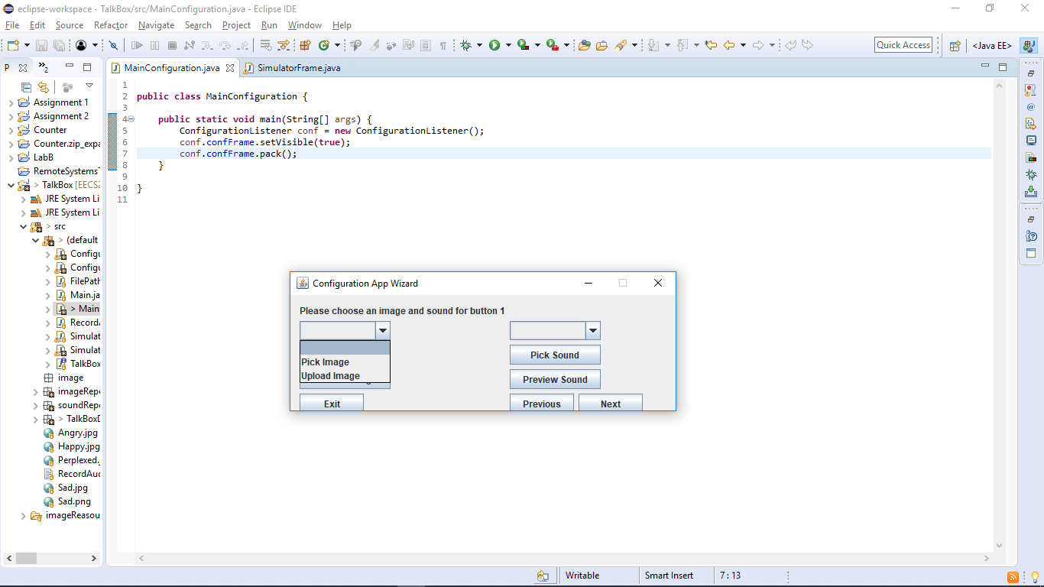

* For the image list the user is prompted with two options: Pick Image, and Upload image, the window changes respectively depending on the choice:

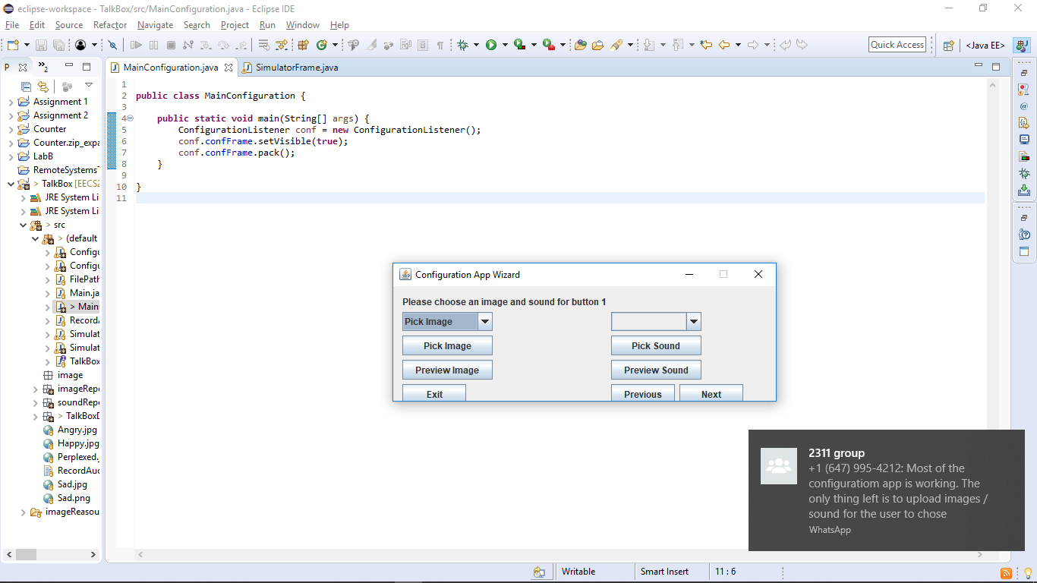 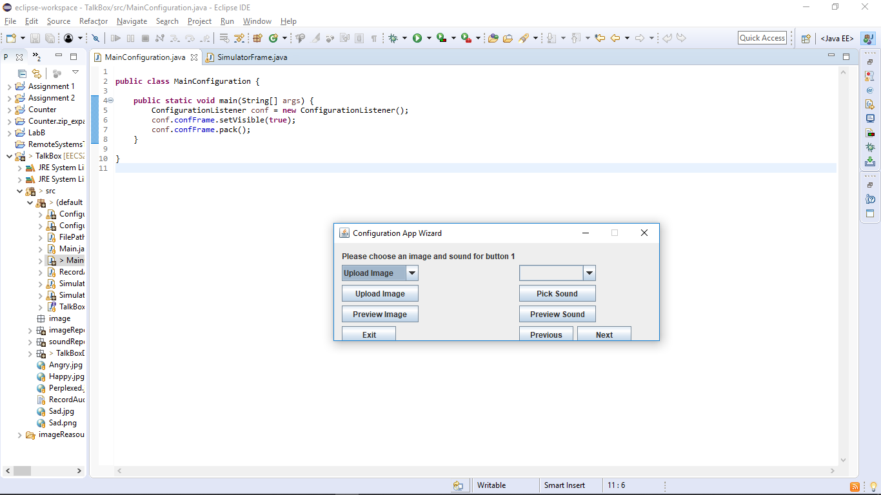

* The respective “Pick Image” and “Upload Image” take you to different windows. The Pick Image button takes you to a folder containing default images, this button is present for convenience. The Upload Image button takes you to your Desktop in case you want to customize your own TalkBox:

Pick Image: Upload Image:

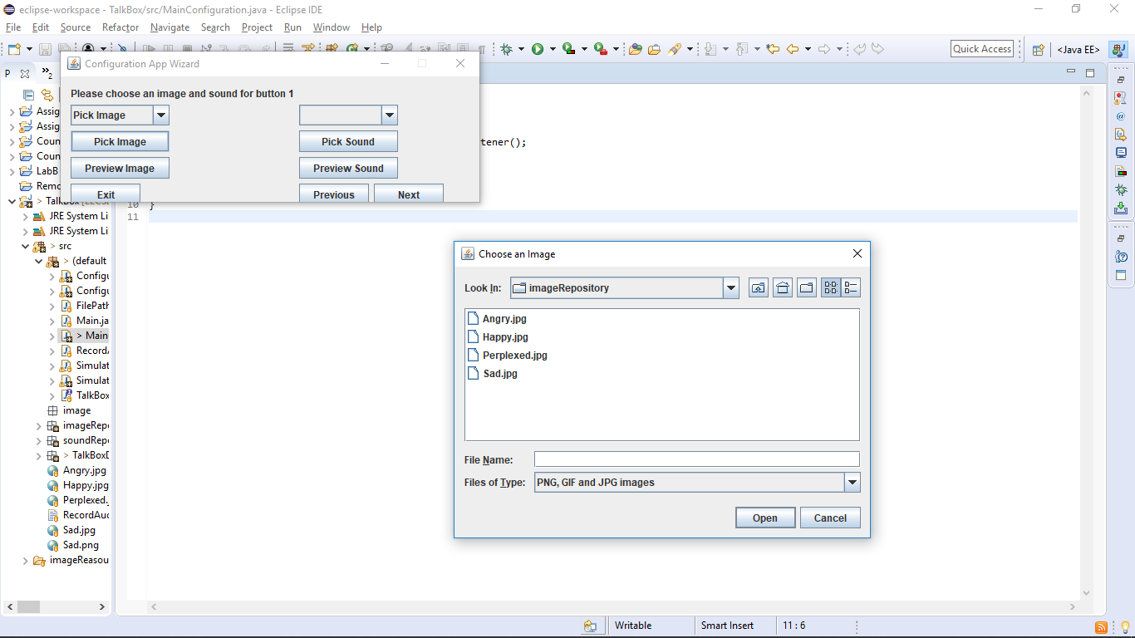 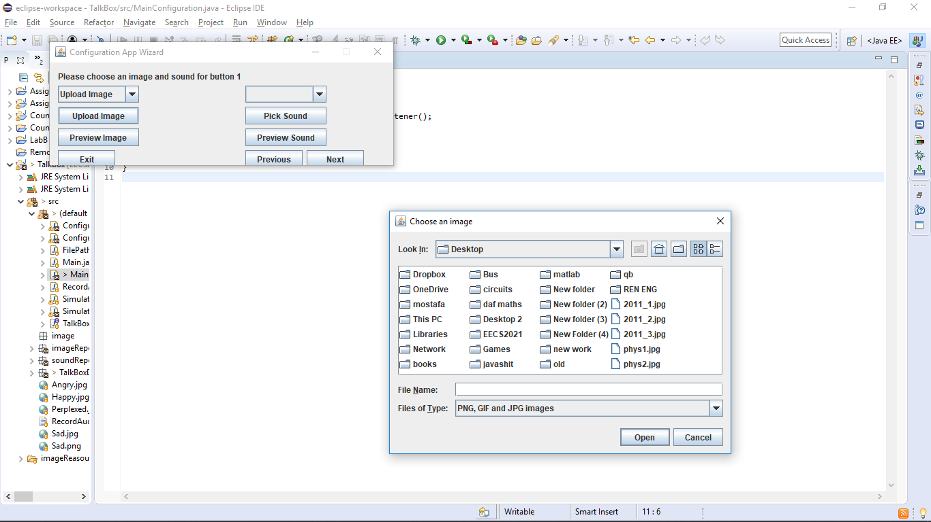

* 1. Sound :

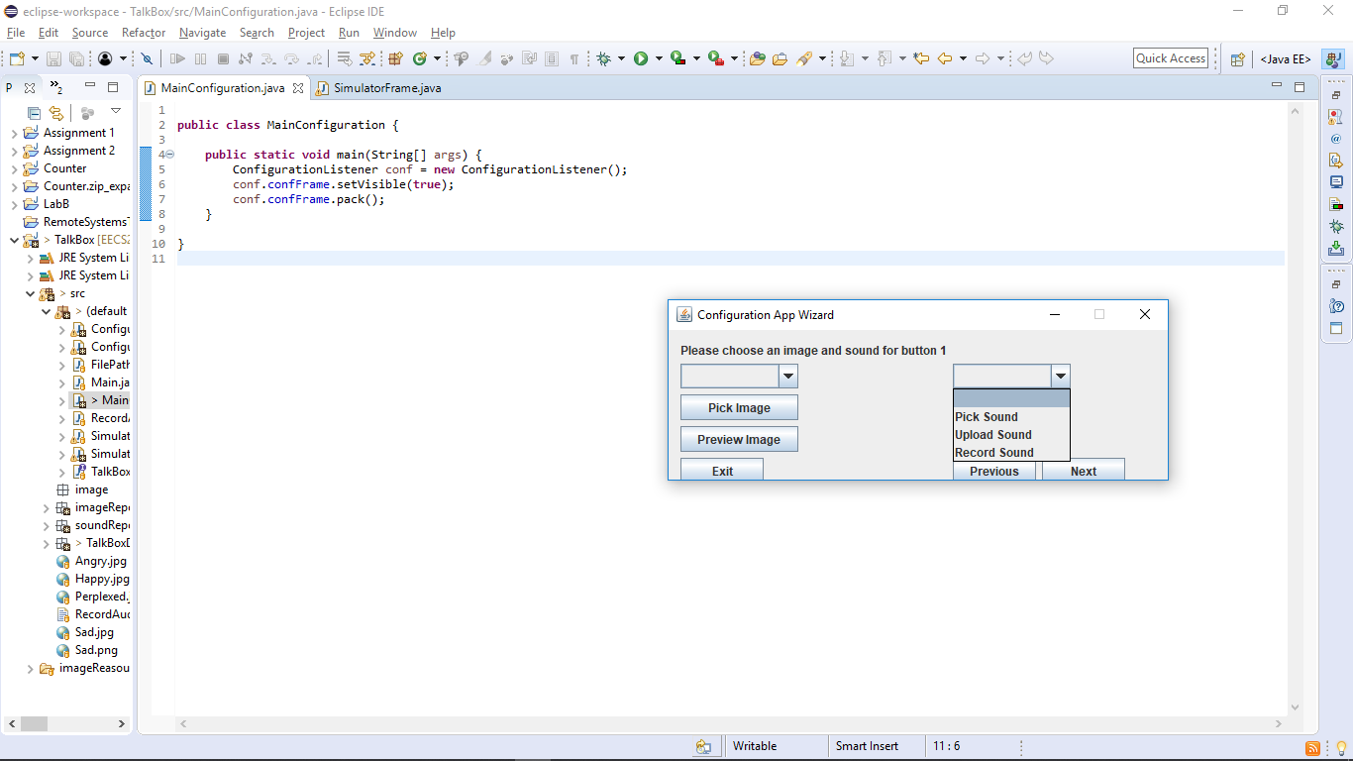

* For the sound list, the user is prompted with 3 options. The « Pick Sound » and « Upload Sound » are identical to the ones for the Image list. However, the « Record Sound » button permits the user to record their own sound and it changes the window to this :

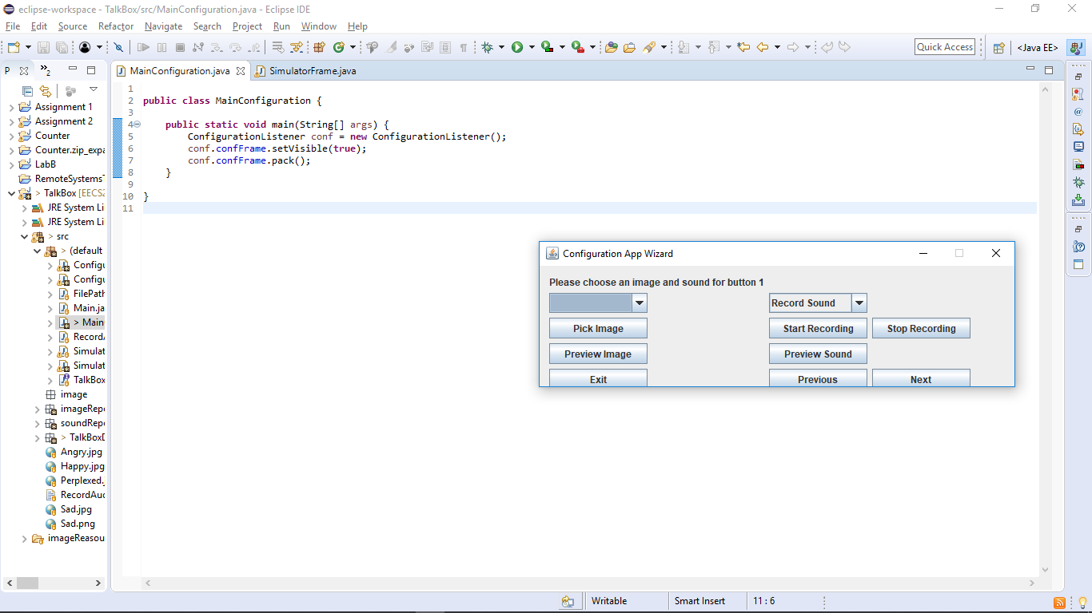

* The « Start Recording » button will prompt the user to speak into a connected microphone, and the « Stop Recording » Button will halt the recording and upload ot automatically.

1. After picking the desired image and sound, you can proceed my previewing the image/ sound to see how it will look in the simulator by clicking on “Preview Image” and “Preview Sound”

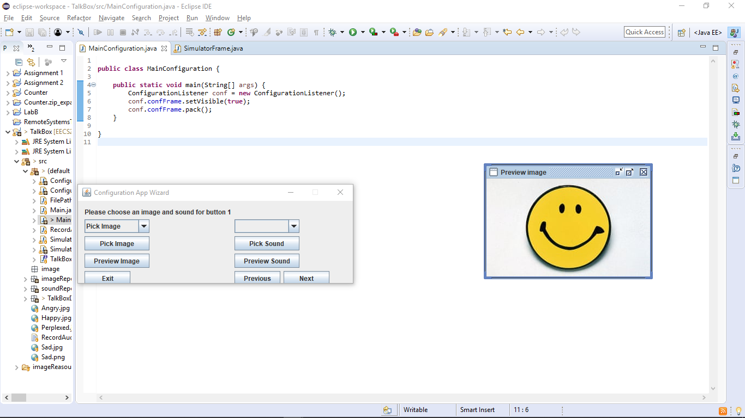

1. The Next button will take you to another window to configure your next button. You can keep track of which button you are currently changing by reading the first sentence. This will specify the button # for you.
2. The Previous button will take you to the previous button you altered in case you need to change its configuration.
3. The exit button will immediately exit the Configuration App Wizard.
4. After configuring all the buttons, and clicking on the final Next button, this window will appear:

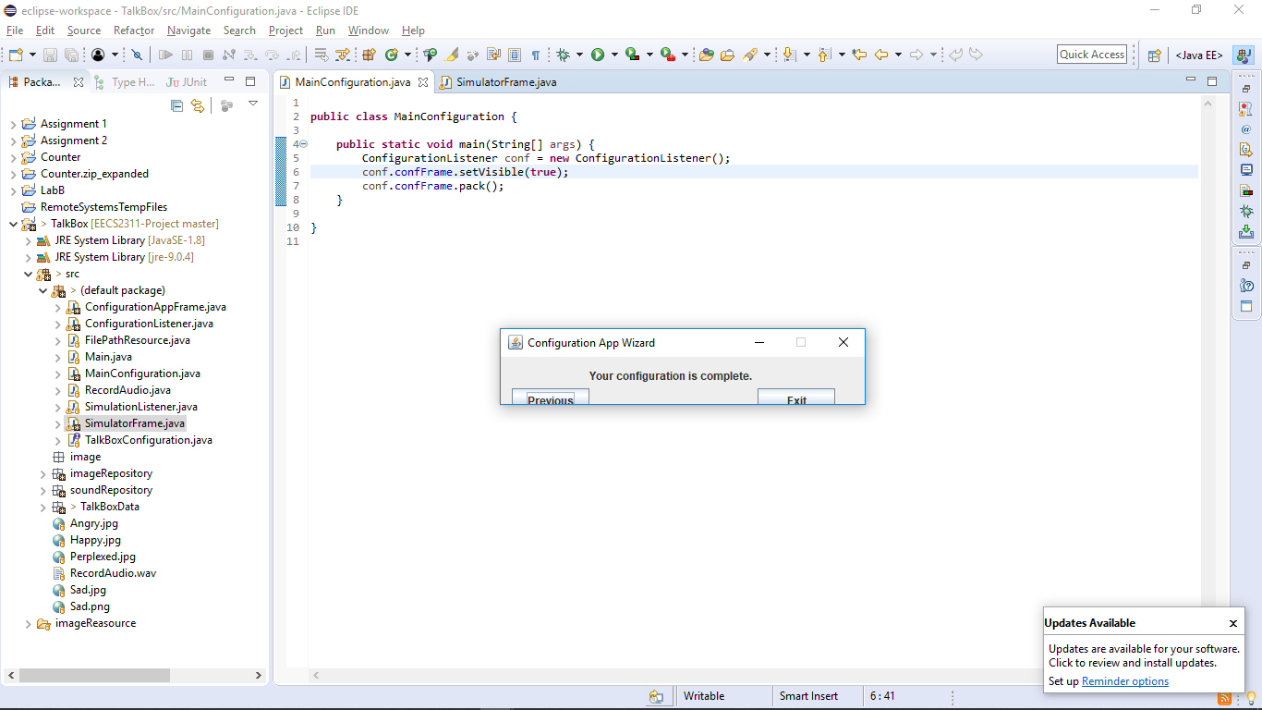

1. Pressing Exit will close the configuration Wizard and save the changes made to the Frame, this is the resulting Frame after having configured 4 buttons. Clicking the buttons will play their respective sound.

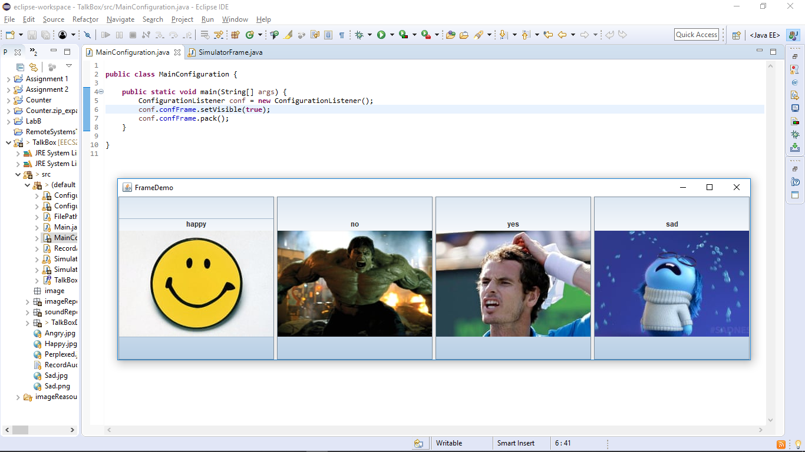

Major Use Cases:

In a more general sense, the main functionalities of the device are accepting audio files and text/images as input, and then outputting audio depending on the user’s needs.

It supports the ability to function in school/workspace, support sociability. Used to voice certain emotions and states. Thus, enhancing communication when sensory, motor, and/or linguistic impairments are involved.

Limitations to the device include user input text to speech functionality, to help in outputting customized responses.